Table of Contents

Queries 1

1. Create a table named ‘matches’ with appropriate data types for columns 1

2. Create a table named ‘deliveries’ with appropriate data types for columns 2

3. Select the top 20 rows of the *deliveries*table after ordering them by id, inning, over, ball in ascending order. 3

4. Fetch data of all the matches played on 2nd May 2013 from the *matches*table.. 3

5. Fetch data of all the matches where the result mode is ‘runs’ and margin of victory is more than 100 runs. 4

6. Fetch data of all the matches where the final scores of both teams tied and order it in descending order of the date 4

7. Get the count of cities that have hosted an IPL match. 5

8. Write a query to fetch the total number of boundaries and dot balls from the *deliveries_v02*table. 5

9. Write a query to fetch the total number of boundaries scored by each team from the *deliveries_v02*table and order it in descending order of the number of boundaries scored. 6

10. Write a query to fetch the total number of dot balls bowled by each team and order it in descending order of the total number of dot balls bowled. 7

11. Write a query to fetch the total number of dismissals by dismissal kinds where dismissal kind is not NA 8

12. Write a query to get the top 5 bowlers who conceded maximum extra runs from the *deliveries*table 8

*13.* Write a query to create a table named *deliveries_v03*with all the columns of *deliveries_v02*table and two additional column (named *venue*and *match_date*) of *venue*and *date*from table *matches* 9

14. Write a query to fetch the total runs scored for each venue and order it in the descending order of total runs scored. 10

15. Write a query to fetch the year-wise total runs scored at *Eden Gardens*and order it in the descending order of total runs scored. 10

16. Get unique team1 names from the *matches*table, you will notice that there are two entries for*Rising Pune Supergiant* one with *Rising Pune Supergiant* and another one with *Rising Pune Supergiant****s***.  Your task is to create a *matches_corrected*table with two additional columns *team1_corr*and *team2_corr*containing team names with replacing *Rising Pune Supergiant****s*** with *Rising Pune Supergiant*. Now analyse these newly created columns. 11

17. Create a new table deliveries_v04 with the first column as ball_id containing information of match_id, inning, over and ball separated by ‘-’ (For ex. 335982-1-0-1 match_id-inning-over-ball) and rest of the columns same as deliveries_v03) 11

18. Compare the total count of rows and total count of distinct ball_id in deliveries_v04 11

# Queries

## Create a table named ‘matches’ with appropriate data types for columns

-- Table: public.deliveries

-- DROP TABLE IF EXISTS public.deliveries;

CREATE TABLE IF NOT EXISTS public.deliveries

(

id integer NOT NULL,

inning integer NOT NULL,

over integer,

ball integer,

batsman character varying COLLATE pg_catalog."default",

non_striker character varying COLLATE pg_catalog."default",

bowler character varying COLLATE pg_catalog."default",

batsman_runs integer,

extra_runs integer,

total_runs integer,

is_wicket integer,

dismissal_kind character varying COLLATE pg_catalog."default",

player_dismissed character varying COLLATE pg_catalog."default",

fielder character varying COLLATE pg_catalog."default",

extras_type character varying COLLATE pg_catalog."default",

batting_team character varying COLLATE pg_catalog."default",

bowling_team character varying COLLATE pg_catalog."default",

CONSTRAINT "FK_MATCH_ID" FOREIGN KEY (id)

REFERENCES public.matches ("ID") MATCH SIMPLE

ON UPDATE NO ACTION

ON DELETE NO ACTION

NOT VALID

)

TABLESPACE pg_default;

ALTER TABLE IF EXISTS public.deliveries

OWNER to postgres;

## Create a table named ‘deliveries’ with appropriate data types for columns

-- Table: public.matches

-- DROP TABLE IF EXISTS public.matches;

CREATE TABLE IF NOT EXISTS public.matches

(

id integer NOT NULL,

city character varying COLLATE pg_catalog."default",

date date,

player_of_match character varying COLLATE pg_catalog."default",

venue character varying COLLATE pg_catalog."default",

neutral_venue integer,

team1 character varying COLLATE pg_catalog."default",

team2 character varying COLLATE pg_catalog."default",

toss_winner character varying COLLATE pg_catalog."default",

toss_decision character varying COLLATE pg_catalog."default",

winner character varying COLLATE pg_catalog."default",

result character varying COLLATE pg_catalog."default",

result_margin integer,

eliminator "char",

method character varying COLLATE pg_catalog."default",

umpire1 character varying COLLATE pg_catalog."default",

umpire2 character varying COLLATE pg_catalog."default",

CONSTRAINT "IPL_MATCH_pkey" PRIMARY KEY (id)

)

TABLESPACE pg_default;

ALTER TABLE IF EXISTS public.matches

OWNER to postgres;

## Select the top 20 rows of the *deliveries*table after ordering them by id, inning, over, ball in ascending order.

select

*

from

deliveries

order by

id, inning, over, ball asc

limit 20;

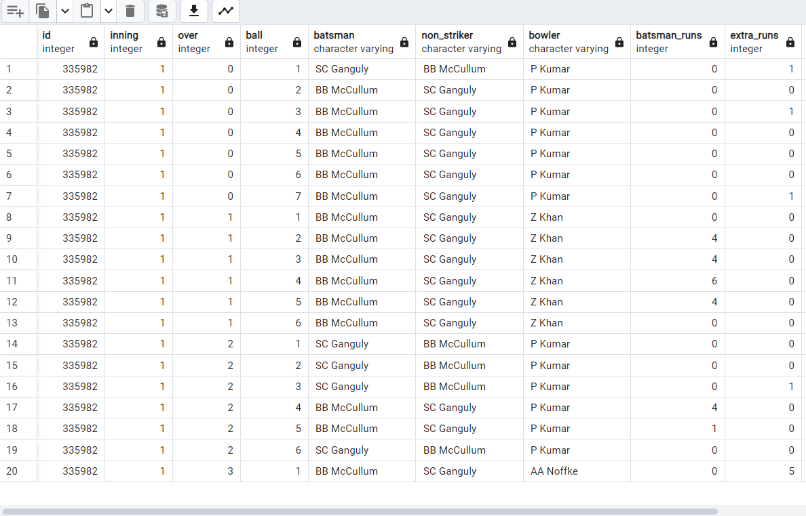

## Fetch data of all the matches played on 2nd May 2013 from the *matches*table..

select

*

from

matches

where

to_char(date,'ddmmyy') = '020513';

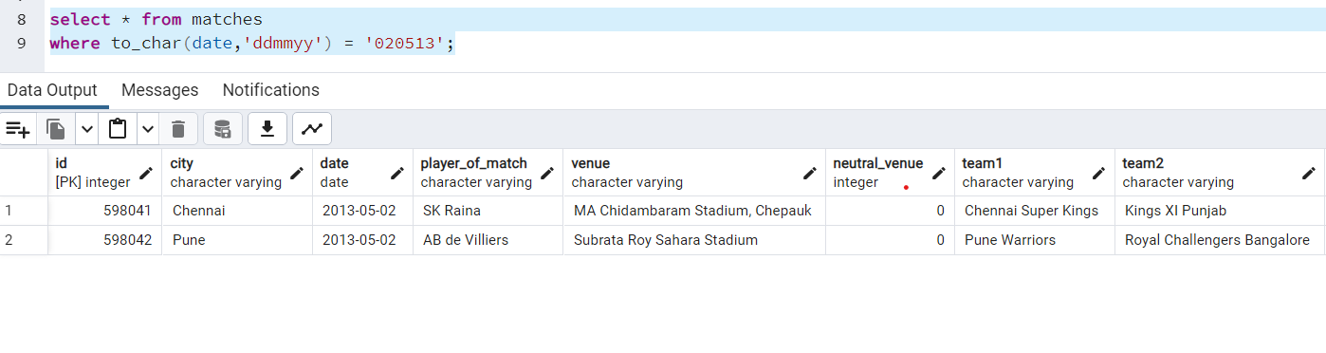

## Fetch data of all the matches where the result mode is ‘runs’ and margin of victory is more than 100 runs.

select

*

from

matches

where

result = 'runs' and result_margin > 100;

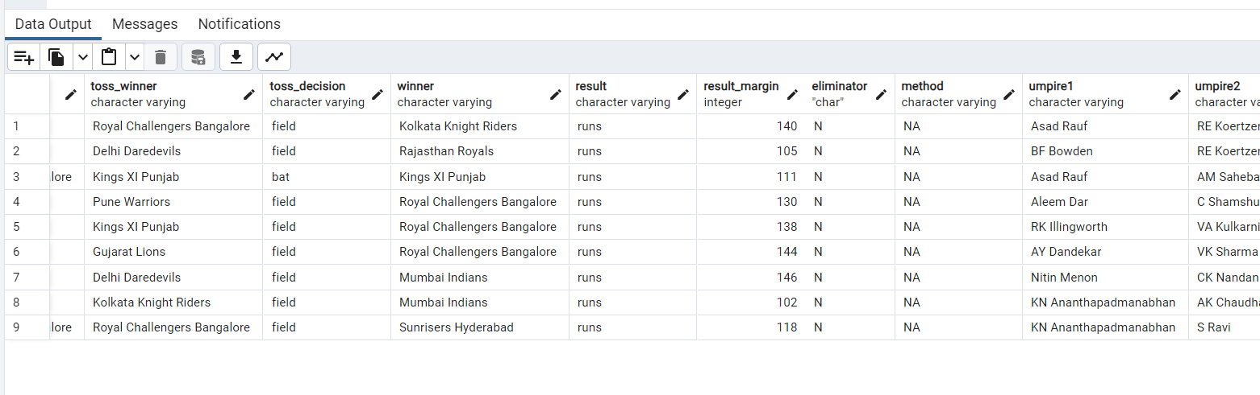

## Fetch data of all the matches where the final scores of both teams tied and order it in descending order of the date

select

*

from

matches

where

result = 'tie'

order by

date desc;

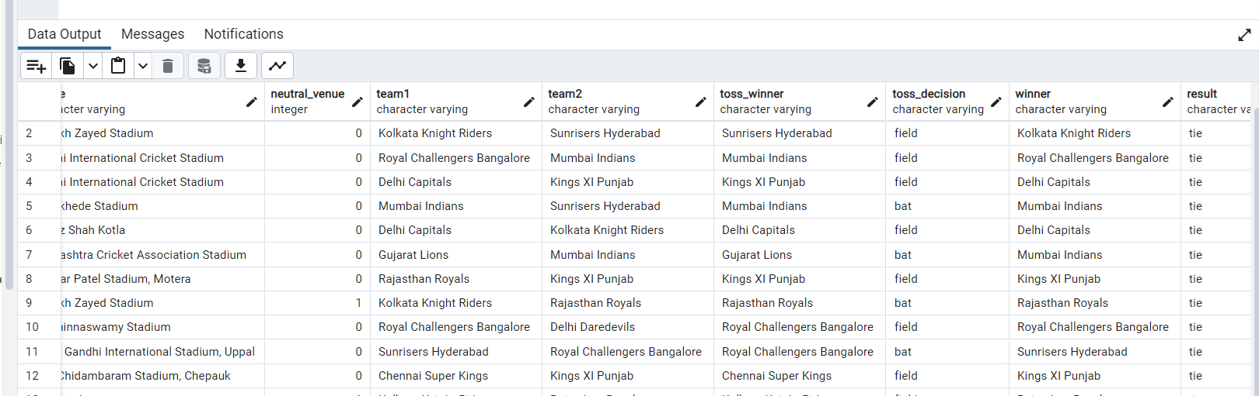

## Get the count of cities that have hosted an IPL match.

select

count(distinct City)

from

matches;

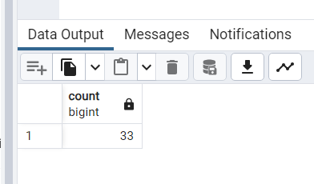

## Write a query to fetch the total number of boundaries and dot balls from the *deliveries_v02*table.

select

ball_result,count(*)

from

deliveries_v02

where

ball_result in ('Dot','Four','Six')

group by

ball_result;

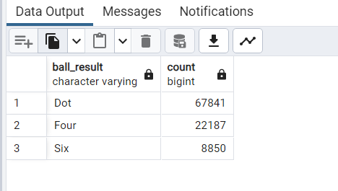

## Write a query to fetch the total number of boundaries scored by each team from the *deliveries_v02*table and order it in descending order of the number of boundaries scored.

select

batting_Team,ball_result,count(*) as Boundaries

from

deliveries_v02

where

ball_result in ('Four','Six')

group by

batting_Team,ball_result

order by

Ball_result Desc, Boundaries desc;

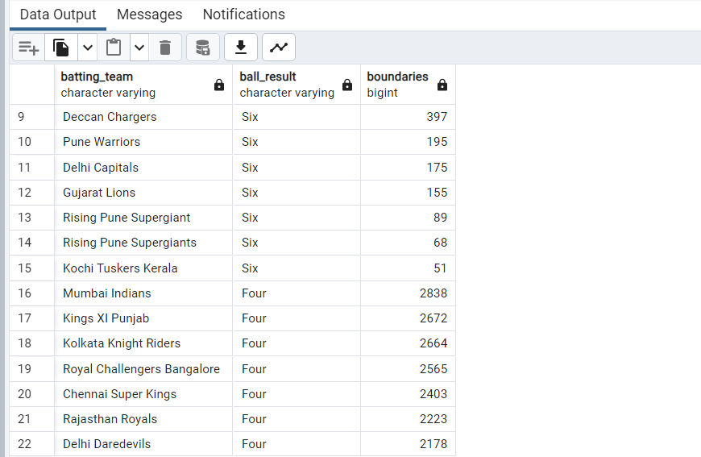

## Write a query to fetch the total number of dot balls bowled by each team and order it in descending order of the total number of dot balls bowled.

select

bowling_Team,ball_result,count(*) as Dots

from

deliveries_v02

where

ball_result in ('Dot')

group by

bowling_Team,ball_result

order by

Dots desc;

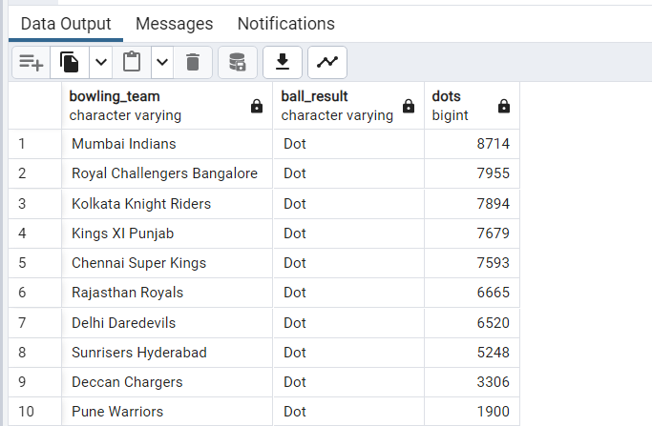

## Write a query to fetch the total number of dismissals by dismissal kinds where dismissal kind is not NA

select

count(*)

from

deliveries

where

dismissal_kind = 'NA';

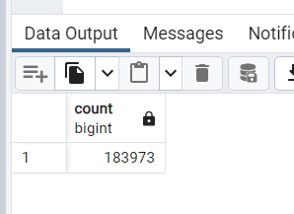

## Write a query to get the top 5 bowlers who conceded maximum extra runs from the *deliveries*table

select

Bowler, sum(Extra_Runs) as Total_Extras

from

deliveries

group by

Bowler

order by

Total_Extras desc

limit 5;

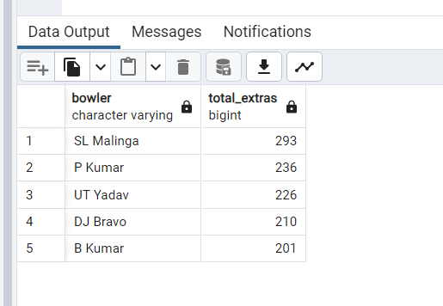

## Write a query to create a table named *deliveries_v03*with all the columns of *deliveries_v02*table and two additional column (named *venue*and *match_date*) of *venue*and *date*from table *matches*

create table deliveries_v03 as

select * from deliveries_v02

where 1 = 2

alter table deliveries_v03

add column venue character varrying;

alter table deliveries_v03

add column Match_date Date;

insert into deliveries_v03

select d.*,m.venue,m.date

from deliveries_v02 as d inner join

matches m on m.id = d.id;

## Write a query to fetch the total runs scored for each venue and order it in the descending order of total runs scored.

select

venue, sum(total_runs)

from

deliveries_v03

group by

venue

order by

sum(total_runs) desc;

select

venue, sum(total_runs)

from

deliveries d inner join matches m

on m.id = d.id

group by

venue

order by

sum(total_runs) desc;

## Write a query to fetch the year-wise total runs scored at *Eden Gardens*and order it in the descending order of total runs scored.

select

to_char(Match_date,'yyyy'),sum(total_runs)

from

deliveries_v03

where

venue = 'Eden Gardens'

group by

to_char(Match_date,'yyyy');

select

to_char(date,'yyyy'),sum(total_runs)

from

deliveries d inner join matches m

on m.id = d.id

where

venue = 'Eden Gardens'

group by

to_char(date,'yyyy');

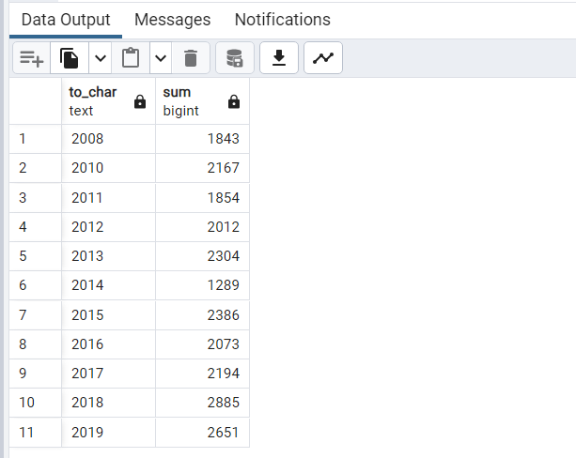

## Get unique team1 names from the *matches*table, you will notice that there are two entries for*Rising Pune Supergiant* one with *Rising Pune Supergiant* and another one with *Rising Pune Supergiant****s***.  Your task is to create a *matches_corrected*table with two additional columns *team1_corr*and *team2_corr*containing team names with replacing *Rising Pune Supergiant****s*** with *Rising Pune Supergiant*. Now analyse these newly created columns.

update matches

set team1 = 'Rising Pune Supergiant',

team2 = 'Rising Pune Supergiant'

where

team1 = 'Rising Pune Supergiants'

or

team2 = 'Rising Pune Supergiants';

## Create a new table deliveries_v04 with the first column as ball_id containing information of match_id, inning, over and ball separated by ‘-’ (For ex. 335982-1-0-1 match_id-inning-over-ball) and rest of the columns same as deliveries_v03)

insert into deliveries_v04

select *, concat(id,'-',inning,'-',over,'-',ball)

from deliveries_v03;

## Compare the total count of rows and total count of distinct ball_id in deliveries_v04

select count(*) total_count ,count(distinct ball_id) ballid_count

from deliveries_v04;

